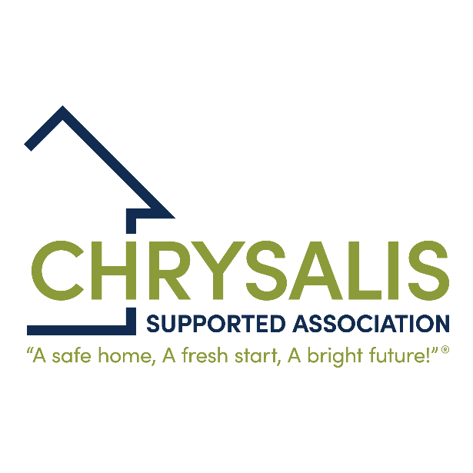

Aids and Adaptations Policy

Contents

1 INTRODUCTION 3
2 SCOPE 3
3 LEGAL AND REGULATORY REQUIREMENTS 3
4 WHAT AND WHO IS COVERED BY THE POLICY? 3
5 FUNDING 4
6 REQUESTS FOR ADAPTATIONS 4
7 MAINTENANCE OF ADAPTATIONS 4
8 REFUSAL OF ADAPTATION REQUESTS 4

- INTRODUCTION

  - This policy sets out Chrysalis Supported Association’s (CSA) approach to carrying out adaptations and aims to support tenants to experience a good quality of life within their homes. This policy and associated service will strike a balance between continuously improving levels of provision and customer service, making best use of housing stock and the need to achieve value for money.

  - As far as practicably possible, CSA will work with the local authority to support customers and enable them to continue to live independently within their home and community, ensuring that their homes remain safe and convenient to use, whilst ensuring efficient management of resources.

  - CSA will work within the framework of our Asset Management Strategy, having regard to investment and maintaining the long-term sustainability of our properties.

  - CSA will develop a register of adapted properties so that, where possible, re-lets can be matched with customers’ individual needs.

  - CSA will publish information on our website to provide detail on how requests for adaptations can be made.

  - If legislative changes mean any of this policy does not comply with the latest current legislation this will override this policy. All other aspects of the policy will remain in force.

- SCOPE

  - This policy applies to the letting of all our properties.

  - All staff, contractors and partners are expected to comply with this policy when letting social rent property on behalf of CSA.

  - This policy has been shared with Chrysalis Maintenance Services who are our delivery partner
- LEGAL AND REGULATORY REQUIREMENTS

  - Under the Consumer Standards ‘Safety and Quality’ standard the Regulator of Social Housing states that registered providers must assist tenants seeking housing adaptations to access appropriate services.

  - The Equality Act 2010 states that “…landlords will be obliged to make certain reasonable adjustments if requested by the customer. Reasonable adjustments do not include the removal or alteration of a physical feature but do include providing auxiliary aids or services, changing practices, policies and procedures and/or changing the term of the letting.”

- WHAT AND WHO IS COVERED BY THE POLICY?

  - For the purposes of this policy, an adaptation is an alteration or addition to any aspect of a property which is provided in order to make it easier or safer for use by the tenant. This may be the named tenant or relatives of the tenant where the tenants have caring responsibilities for them, and they are permanent residents in the home.

- FUNDING

  - Adaptations will be funded either by the tenant, Disabilities Facility Grant (DFG), Adult Social Care or other relevant funds.

- REQUESTS FOR ADAPTATIONS

  - Adaptations can be requested by customers and/or their representatives. CSA may be able to support with simple adaptations, such as the installation of grabrails, following an assessment from an Occupational Therapist and confirmation of funding.

  - All request for adaptations will be considered and approval not unreasonably withheld.

- MAINTENANCE OF ADAPTATIONS

  - Specialist aids and adaptations may require external specialist maintenance. This must be arranged by and have costs met by the funding party.

- REFUSAL OF ADAPTATION REQUESTS

  - CSA are unlikely to approve a major adaptation where the benefit achieved for the resident is short term or it is not reasonable or practicable. Such circumstances may include:

- Where the customer is actively seeking rehousing.
- When the adaptation requested is not structurally practicable.
- When a major adaptation will not result in a significant benefit to the customer.

  - Where it is not reasonably practical to carry out the necessary adaptations to enable the customer to live independently in their own home, CSA will support the customer to find alternative accommodation which matches their housing requirement and need, making best use of existing stock. CSA may also provide support with the cost of moving to a suitable property.

Related documents
HM02 | Allocations Policy
HM08 | Repairs and Maintenance Policy

